# Agreement

A social media site that allows users to create and share posts, discuss topics with other users, and follow other users and topics of interest. The site will be designed to be a web and desktop application and easily accessible for users of all technical backgrounds.

# Functional requirements

**1.1 User profiles**

Each user should have a profile page that displays their basic information (e.g. name, profile picture, bio). Users should be able to edit and customize their profile.

**1.2 News feed**

The site should have a news feed that displays posts and discussions from other users in a chronological order. Users should be able to upvote/downvote posts, and the most popular posts should be displayed at the top of the news feed. In the home feed, only posts from communities that the user is following would be displayed.

**1.3 Moderation features**

Users should be able to report inappropriate content or behavior on the site. Moderators should be able to review reported content and take appropriate action, such as removing or hiding posts.

**1.4 Search functionality**

The site should have a search function that allows users to search for different users and communities. The user can type in a keyword to search for users/communities.

**1.5 Following system**

Users should be able to follow other users or topics of interest. When a user follows a topic, they should see posts and discussions related to that topic in their news feed.

**1.6 Notification system**

The site should have a notification system that alerts users of new activity on their posts. Notifications should be displayed in a clear and organized manner.

# Non functional requirements

**Performance**

The site should be able to handle a large number(1K users) of users and posts without slowing down or crashing. Load testing should be conducted to ensure the site can handle peak traffic.

**Security**

The site should have a secure login system and use encryption to protect user data. Measures should be taken to prevent unauthorized access, hacking, or data breaches.

**Usability**

The site should be user-friendly and easy to navigate, with clear labels and instructions. User testing should be conducted to ensure the site is easy to use for users of all technical backgrounds.

# Acceptance criteria

The site will be considered acceptable if it meets the following criterias

1. There are no bugs in the application.
2. The application has passed all the test cases.

# Use cases

**Use Case 1: User Login**

Primary Actor: User

Preconditions:

1. User must have access to the social media site.

Main success scenario :

1. User fills in the login details
2. System validates the username and password.
3. The system shows the main feed page to the user

Postconditions:

1. User is logged in to their account and can access all the features of the social media site.

**Use Case 2 : User Signup**

Actors : User

Preconditions :

1. User is on the signup page

Main success scenario :

1. User fills in the signup details and conforms
2. System validates the signup details
3. System confirms that the signup details are valid
4. The system shows the main feed page to user.

Postconditions

1. User has full access to all the features on the social media site

**Use Case 3: Upvote post**

Actors: User

Preconditions:

1. User is registered and logged in to the social media site
2. User has access to the internet and a device to access the social media site

Main success scenario:

1. User navigates to the page displaying posts.
2. User indicates that he wants to upvote the post
3. System validates this and displays the updated post score

Post-Conditions:

1. The post is successfully upvoted and is displayed to user

**Use case 4 : Downvote post**

Primary Actor: User

Preconditions:

1. The user is logged in to the social media site.
2. User has access to the internet and a device to access the social media site

Main success scenario:

1. The user navigates to the page displaying posts
2. User indicates that he wants to downvote the post
3. The system validates this and shows the updated post score

Postconditions:

1. The user successfully downvoted the post and can view the updated post score

**Use Case 5 : Upvote comment**

Primary Actor: User

Preconditions:

1. The user is logged in to the social media site
2. User has access to the internet and a device to access the social media site

Main success scenario:

1. The user navigates to the comment
2. User indicates that he wants to upvote the comment
3. System validates this and shows the comment with the updated comment score.

Postconditions:

1. The user successfully upvoted the comment and the user can view the updated score.

**Use Case 6: Downvote comment**

Primary Actor: User

Preconditions:

1. The user is logged in to the social media site
2. User has access to the internet and a device to access the social media site

Main success scenario:

1. The user navigates to the comment
2. The user indicates that he wants to downvote the comment
3. System validates this and shows the comment with the updated score

Post-conditions:

1. The user successfully downvoted the comment and the user can view the updated score.

**Use Case 7 : Follow community**

Actors: user

Preconditions:

1. The user is logged in to the social media site

Main success scenario:

1. The user navigates to the community page that he wants to follow
2. The user indicates that he wants to follow the community
3. System validates this and confirms by displaying message

Alternate Flows:

1. If the user is already following the community, the system displays a message indicating that the user is already following the community.

Postconditions:

1. The user is now following the community and its posts are displayed in user’s feed page

**Use case 8 : Unfollow community**

Actors: user

Preconditions:

1. The user is logged in to the social media site

Main success scenario:

1. The user navigates the community page that he wants to unfollow
2. The user indicates that he wants to unfollow the community
3. The system validates this and conforms by displaying message

Alternative flows:

1. If the user is not following the community, the system displays a message indicating that the user is not following the community.

Postcondition

1. The user has now unfollowed the community and its posts will not be displayed in his feed page.

**Use case 9 : Edit post**

Actor : user

Precondition :

1. User is logged in has a post created

Main success scenario

1. User navigates to the post he wants to edit.
2. The user indicates that he wants to edit the post
3. The system takes him to the edit post page
4. The user edits the post
5. System validates this by displaying a message

Postcondition

1. The post was successfully edited and the new edited post will be displayed

**Use case 10 : Edit comment**

Actor : user

Precondition :

1. User is logged in to the site and has a comment created

Main success scenario

1. User navigates to the comment he wants to edit
2. The user indicates that he wants to edit the comment
3. The system takes him to the edit comment page
4. The user edits the comment
5. System validates this by displaying a message

Postcondition

1. The comment was successfully edited and the new edited comment will be displayed.

**Use case 11 : Create post**

Actor : user

Precondition :

1. User is logged in to the site

Main success scenario

1. User navigates to the create post page
2. User fills in all the required information
3. System validates this and displays a success message

Post condition :

1. The post will be displayed in the browse community page

**Use case 12 : Create comment**

Actor : user

Precondition:

1. User is logged in
2. There is a post under which user can add comment

Main success scenario

1. User navigates to the create comment page
2. User enters the comment
3. System validates this by displaying the comment under the post.

Post condition

1. The user can now view the created comment user the post

**Use case 13 : Delete post**

Actor : user

Precondition :

1. User is logged in
2. User has created a post that he wishes to delete

Main success scenario

1. User navigates to the post he wants to delete
2. User indicates that he wants to delete the post
3. System deletes the post

Post conditions

1. The post is deleted and cannot be retrieved

**Use case 14 : Delete comment**

Actor : user

Preconditions

1. User is logged in
2. User has created a comment that he wishes to delete

Main success scenario

1. User navigates to the comment he wants to delete
2. User indicates that he wants to delete the comment
3. System deletes the comment

Post conditions

1. The comment is successfully deleted and cannot be retrieved

**Use case 15 : Remove post**

Actor : user

Preconditions

1. User is logged in
2. The user is the moderator for the community

Main success scenario

1. The user navigates to the post he wants to remove in the community
2. The user indicates that he wants to remove post
3. The system removes the post

Post conditions

1. The post will not be showed in anyone feed and it is possible to retrieve this post in the future

**Use case 16 : Create community**

Actor : Premium user

Precondition

1. User is running the forms app
2. User is a premium user

Main success scenario

1. User navigates to the create community tab
2. User fills in all the information to create community
3. User indicates the he wants to create community
4. The system validates and displayed message

Post conditions

1. The community is created and ready to be used.

**Use case 17 : Send message**

Actor : user

Precondition :

1. User is running the forms app and is logged in

Main success scenario

1. User navigates to the message tab
2. User fills in all the details to create message
3. User indicates that he wants to send message
4. System validates and confirms this.

Post conditions

1. The message will be sent.

# Wireframes

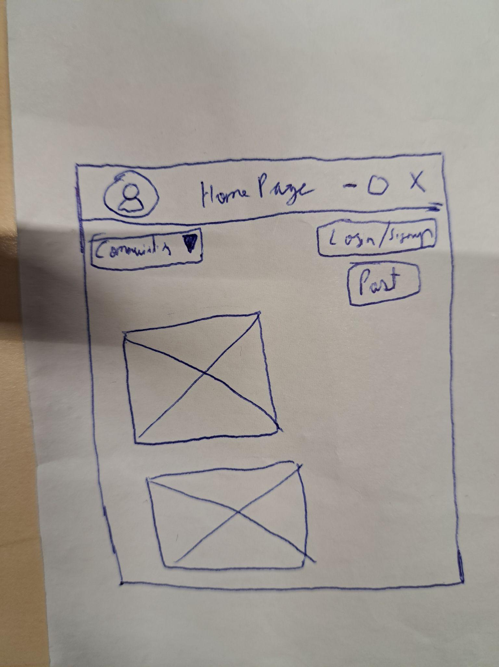

Feed page use to display feed

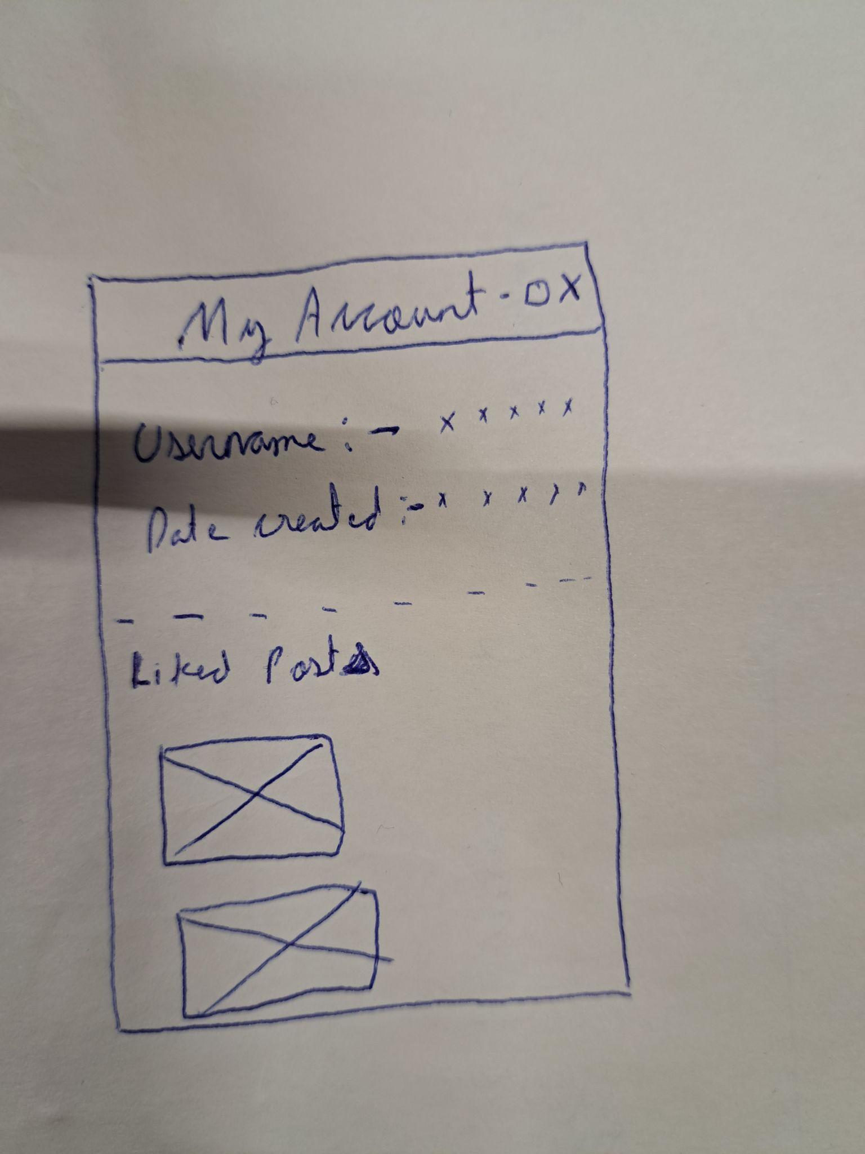

Ussr profile page

# Moscow requirements

## Must have

1. User registration and login functionality
2. Ability for users to create and edit their profile
3. A news feed where users can see posts and discussions from other users
4. Upvoting and downvoting system to rate posts and comments
5. Moderation features to allow users to report inappropriate content or behavior
6. Search functionality to allow users to find specific posts or topics
7. Ability for users to follow other users or topics of interest
8. Private messaging system for users to communicate with each other

## Should have

1. Ability for users to create and join groups or communities based on shared interests
2. Algorithmic recommendation system to suggest content to users based on their activity and interests
3. Advanced search functionality, such as filtering by date, popularity, or relevance
4. Notification system to alert users of new activity on their posts or in topics they follow

## Could have

1. Live chat functionality for real-time discussions
2. Audio and video posting capabilities

## Won't have

1. Integration with cryptocurrency payment systems
2. Ads
3. Non-English language support